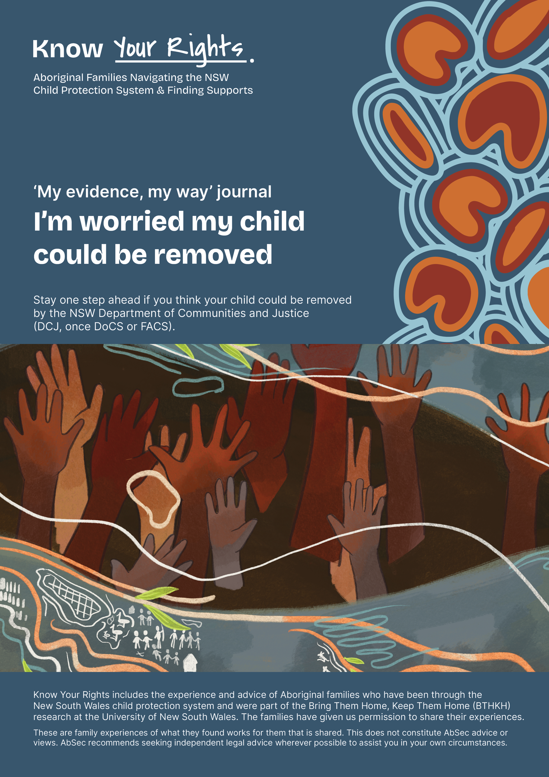

‘My evidence, my way’ journal
What I know, what I can show.

Parents understand the child protection system as a game that they do not have much power in. The NSW Department of Communities and Justice (DCJ) and other services collect evidence that is used in Court. These questions come from parents who have learned the hard way to understand or record what has happened and what might happen based on how DCJ is playing the game.
It’s up to you to choose to share what you want to with DCJ. These guides were created for you as a parent to reflect on your strengths and record your side of the story with DCJ. Please be mindful of what information is shared with DCJ. These guides were created to collect your own evidence and help assist you to reflect, for your wellbeing.
You can answer these questions however suits you best. In your head or write them down or put them in a voice recorder or do this with someone you trust and who will never use this against you.
Not all questions will be useful for you so choose what you want, when and how you want to.
Remember, you can always access your own independent legal advice to help you in your interactions with DCJ. For legal and other important contacts, see the Know Your Rights (KYR) Guide ‘Key Contacts.’

Contents
Playing the Game 4
If you Think your Child will be Removed 6
Yarn with family/kin to stay one step ahead 7
Legal Advice or Representation 11
Safety Assessment 13
The Family Based Assessment (Risk Assessment) 18
Family Action Plans for Change (FAP-C) 21

Playing the Game
- What have I learned about the way DCJ works? How do I know this? Has my family changed how we deal with DCJ because of this?

- Have I been given the necessary information and documents (assessments, case plans, safety plans, family action plan) that are about me, my kids and our family?

- Have I received legal advice? What have they said? Do I agree with them?

- What has DCJ said about me?
  - Have they said things that are not true? Have they manipulated the facts? Have they left important details out of their reports?
  - Has DCJ given me case notes or affidavits that are out of context?
  - What has been my experience of these things?

- Do I have a support person or service that is supporting me?

- Has a DCJ caseworker ever said that they would do something for me but not followed through? Have I ever gotten these promises they made in writing?
(The next time that DCJ says that they will do something, I will ask for them to confirm it in an email or text message and screenshot this to use as proof for if they don’t follow through).

- Have I documented the dates and times of when interactions with DCJ happened?
(e.g phone calls, meetings).

- Have I kept records of the times and dates of when I completed the tasks that DCJ wants me to do?
(e.g. parenting courses, counselling, drug tests etc.).

- What are some examples of ‘strategic compliance’ that I have done? Strategic compliance means that you do more than what caseworkers tell you to do. It can feel like ‘jumping through hoops’, but it can be used to beat DCJ at their own game.
(e.g. choosing to do urinalysis after DCJ stop requiring it, doing multiple parenting courses when DCJ only tell you to do one).

- Do I have a plan or system of storing evidence that works for me?
(e.g. setting up a separate email account, photos and screenshots, using a Dropbox or Google Drive account to store files, writing things down in a physical notebook or calendar, using voice recordings to capture memories of incidents while they are still fresh, printing out documents to keep in a folder, using voice-to-text function on smartphones so that you don’t have to type out notes).
- Have I checked that DCJ has accurately shared my progress with the Courts, such as doing parenting courses or being involved with services?

If you Think your Child will be Removed
You may need to think about who your child stays with while you are trying to get them back.
If your child may stay there for a longer time, think about if there is someone who supports your relationship with your child, supports your time together, speaks positively and fairly about you, and supports your child coming home.
- Who is the person, or who are the people that I would want my kids to live with if they were taken from me? Why?

- Who do I not want my kids to live with? Why not?

- How would I want them to take care of them?

- What would I want the carers to know about me as a person and a parent?

- What family and cultural traditions and routines are important for my kids to continue with?

- What will they need to take with them?

- What do I want them to take with them (Medications, toys, comforter, blanket, uniform, clothes, photos)?

- What was it like to think about these questions?

Yarn with family/kin to stay one step ahead

Steps
- Who are my people who support me and who I trust?
- Who are people that I can trust to share stuff with?
- Who is kind to me?
- Who do I think is reliable?
- Who gives me helpful advice?
- Who are some people who might be able to support me, but I need to build my relationship with them or build more trust with them first?
- When I reach out to people for support, what am I worried about (e.g. have other people let me down before)?
- If there are people I want to bring into my circle of support, what do I want them to know about what is important to me (so I can trust them more)? Who can I bring together to create a plan?
- Can we bring them all together to a family yarn up? Or should I speak with them separately to help us get through this time? Will family history get in the way? Or will they put that aside to help me and my children?
- Maybe certain people are better at supporting me through some things but not others. (e.g. my sister helps me deal with my drug use but judges me about the violence) Who are these people and what are they better at helping me with and what are they not so good at helping me with?

- How will I bring them together? Who will organise, where, when, and how? Will services help?
- What are some organisations, or community groups that I can use to get more help if needed?
- What things do these people or groups give me that are helpful? (e.g. specific skills, childcare, transportation, cleaning, cooking, emotional support, access to technology or Wi-Fi, organisation and planning).
- How am I able to work together with them? What are the different ways that I communicate my needs and stay connected with them?
- Are there any boundaries with these people? (e.g. topics that are off-limits, or certain ways or times that each person would prefer to communicate)
- How much privacy and confidentiality can we expect from each other?

- Are there some people who are on my team but cannot come to the yarn up? How will I include them in the plan?

- Who can help make this yarn up go smoothly? Who has cultural/ family authority, like a strong aunty or loving uncle?

- Who will write stuff up?

- What will people do if the plan goes wobbly?

- Are people ok with me sharing this plan with DCJ?

- Does my partner/ my child’s parent need their own separate plan?

- What do I think DCJ will say about the plan?

Questions for the Yarn Up
- What adults are involved in my kid’s lives?

- How do they help to raise my kids?

- How does my family and community support me? Who gives me support in the good times and the hard times?

- What is happening for us and our family right now? List things that might be challenging.

- Could this be a short-term crisis or are there long-term challenges happening?

- Who can make a difference in our lives when we are dealing with these challenges?

- Why does DCJ say they are involved? What are the things that we (mum/dad/nan/pop/aunty/cousin) are good at or that we know a lot about?

- Are there any things we would like to improve or work on?

- What are our plans moving forward? (use the template we have provided here to help guide the planning). Who will do what and when?

- What is our plan for if our kids are taken? Is there someone who can take on formal parental responsibility with DCJ for our kids if DCJ say I’m not allowed to?

- Who can our kids live with if they are removed? List three possible options (plus their contact information).

- Can we decide on what we disagree with, agree with, or could go above and beyond in the goals. Can we decide on which people will do specific things to support me?

- Can we talk about how we will approach DCJ? Do I want my family members to discuss my struggles with DCJ or not? Are there some things I’m okay with them talking about, but not others? (DCJ will try to gather evidence from family members).

- How can my family show DCJ all of the support I have?

- How will we know if or when to share this plan with DCJ?

Legal Advice or Representation
All parents of Aboriginal children that are interacting with DCJ in NSW can and should get independent legal assistance from the Aboriginal Legal Service or another legal service.

Legal support
- Do I know about anyone who has a good child protection lawyer?

- If I contacted the Aboriginal Legal Service or another legal service, what did they say?

Who
- Who did I speak with, and what are their details? Will they be my lawyer?

What
- When I spoke to them, what information stood out to me and why?

How
- Do I feel supported and respected? Do I think I can trust this lawyer?

- Did I agree with the things they said?

- Am I okay with what they said? How did it make me feel?

Next steps
- What did they say are the next steps of things I need to do? What do I want to happen?

- If DCJ has given me goals, did the lawyer say that we can push back on any of them? Or did they tell me to do what DCJ is telling me to do? Do I feel okay with their instructions?

- If I don’t think that this lawyer will follow my instructions or advocate for me and my family, where can I find another lawyer? Who is a supportive person that I can talk to about this?

- Have I been offered a Guardian Ad Litem (GAL)? Have I been told what this is? Do I want one? (A GAL advocates for people who need help representing themselves in the Court process, usually because of things like age, mental incapacity, or other circumstances).

Safety Assessment

When and how
- When and how did DCJ get involved (e.g. home visit, phone call)? Keep a record of any calls or visits (e.g. write notes, take photos).

- Who contacted me? (List the names of the people who contacted me and their contact details).

- Did DCJ turn up at my home unannounced, or did they call to let me know they were coming
(e.g. a phone call)?

- What were DCJ saying? Did I agree with what they were saying?

- What did DCJ say they were worried about? Do I agree? Or do I think this is a false or vexatious (mean) allegation?
(e.g. did someone make this up to get back at me or because they wanted my kids taken off me?)

- What did they say about what their role is and why they have become involved with me and my family?

What did I do?
- What did I tell them? (Try to be as specific as you can about the things you said as DCJ will keep their own records).
Are there any other details from the conversation with them that I think are important to write down?

Respect and understanding
- Do I think that DCJ understood the things I told them?

- Did DCJ communicate in a way that I could understand? If they didn’t, who can I ask to help me understand?

- How did I respond? What things did I say or do?

- Why did I respond this way?

- How did they treat me? Did they believe me? Was I respected and were my ideas respected? How did they make me feel?

Supports
- Did they tell me that I can access independent legal advice and that they can make the referral for me?
(e.g. through the Legal Assistance for Families: Partnership Agreement – LAFPA).

- Did I have a person supporting me when DCJ spoke to me (any witnesses)? Did they take notes? Did DCJ tell me that I am allowed to have a support person at meetings?

My children
- Did DCJ speak with my kids? If they did, how are my kids feeling, thinking or acting now?

- If my kids told me what they were interviewed about, what did they say DCJ asked them and how they answered?

- Where did DCJ interview my kids? If the interview happened at school, a hospital or another place, what do I think it will be like for the kids to have to go back there?

- Did the caseworkers treat my kids with respect? What did they do?

Context
- What time of day did they arrive? What else was going on around the time they got there?

- Did DCJ say when they will contact me next? What did they say will happen next?

Truth
- Now that I have had some time to think about what happened, do I think that what they are saying about me and my family is true? If it is not true, what would I like them to know or understand?

Useful
- If they are true, do I think this safety plan will be helpful?

- Do I have a copy of the safety plan? What things did I agree to do? Do I still agree to do them?

Realistic
- Did DCJ give me a list of the things I have to do? If they did, what are these tasks and how long do I have to complete them?
- Do I think the plan is realistic and reasonable? Or does the plan set us up to fail?
(e.g. can I complete the actions in the amount of time they gave me? Have they made me responsible for something I don’t have control over or can’t do?).

Respect and fairness
- Do I want to make a complaint about how I was treated?

- What did DCJ say was the outcome of the safety assessment?
(e.g. safe, safe with a plan, unsafe).

Safety
- If they took my kids, were they actually unsafe?

- If they were safe, how do I know this?

- Am I safe now or did DCJ leave me to deal with the danger or lack of safety by myself?

- Were there any other options than to take my kids? What did DCJ say was the reason for why they did not consider the options?

Next steps
- Is there anything I can do right now to address their concerns and get ahead of their game?
  - Have a family gathering to decide how we will all approach DCJ
  - Get ahead of what DCJ wants me to do
  - Get support letters from the community and my support networks
  - Seek legal advice and legal representation
  - Book into programs and services relevant to you
  - Document the dates and times of my actions/referrals to provide evidence

- What did they say will happen next?

- Do I have any other questions? Who can answer my questions?
(e.g. lawyer, caseworker, or support person/advocate).

- If I didn’t agree with what's in the safety plan, did I say to DCJ I don’t agree?

Supports
- What has DCJ said they will do to help me achieve these goals?

- What did I sign and did I understand what I was signing?
  - Did I get the opportunity to contact a lawyer before signing?
  - Did they explain the documents to me?
  - Did they give me time to consider what the documents were? If so, how long did they give me to read and consider the information?
  - Did they explain the reasons for why they said I had to sign the documents?
  - Did they say that something else would happen to me or my kids if I did not sign the documents now?

The Family Based Assessment (Risk Assessment)

Who
- Who was involved in the Family Based Assessment?

- What were their names and which office did they come from?

What
- What did they say?

- Did I have a support person there? Did DCJ tell me I’m allowed to have someone there?

How
- How did I respond? (What did I say or do?)

- What did other people that were there say or do?

- How did DCJ describe their concerns about my family or what they think the risks are?

- Did they say anything that was untrue?

Understanding us
- Do I think that DCJ understand what is going on for me and my family?

- What are the things that I believe DCJ misunderstood?

- How do I know that DCJ has not understood my family’s situation?

- Did I agree with what they were saying? What things do I disagree with?

- What did they say they were going to do next?
(e.g. a family group conference, family action plan, other).
- What do I think about these next steps?
- Will they help?
- If not, what am I worried about?

- Did DCJ ask about my family/mob that also have responsibility in raising my kids? Did they include them in the plan?

Fairness
- If this is relevant, do I think they blamed me for experiencing violence? What things did DCJ do or say to blame me for experiencing violence?

- What things did DCJ do to hold the person using violence accountable for their actions? Were there things they did not do in holding that person accountable for their actions?

- Did DCJ do something overly intrusive (went too far).
(e.g. looked through closed cupboards, went through drawers and clothes, and your bins).

Reflecting
- Did I get a copy of my assessment? Did I ask for the paperwork in person or in writing? What was the caseworker’s response when I requested the document?

- Was there anything they said in the paperwork that was true, untrue or not accurate?

- Based on what I have seen and heard, what story do I think DCJ is telling about me and my family?
(e.g. the mother is.... the father is... the kids are...)

- What do I think about this story and what do I think might happen to our family if DCJ continues to tell this story?

- How did I respond when I heard DCJ speaking about us in this way?

- Did I feel respected and culturally safe? What did I notice?

- If domestic violence and/or problem drug or alcohol use is happening in our family, how did DCJ talk to me about this? What words did they use? Did anything stand out to me as especially helpful or unhelpful?

- Am I worried that DCJ are going to take my kids now? If yes, what supports do I have or need?

- Did DCJ give context (what else was going on) when they recorded what you or your child said or did something?

Family Action Plans for Change (FAP-C)

- Do I have a Family Action Plan?
(Every family that DCJ is working with should have one).

- Do I have a copy of it? Have DCJ given this to me?

- Did DCJ write it with me, or did they write it themselves and then tell me to sign it?

- Have I signed it yet? If not, why not?

- Who was involved in the Family Action Plan meeting?
  - Was everyone who needed to be at the meeting there?
  - Was there someone at the meeting who should not have been there?
  - What difference did this make to the way the plan was written?

- Do I agree with the goals, or did I just agree with them at the time?

- Do I agree with what DCJ wrote about in the ‘worries’ section? If not, why not? What did I say to DCJ when they wrote these things? How did they respond to me?

- Are there worries in the Family Action Plan that are not true? What do I think will happen if DCJ keep repeating these allegations that are not accurate? Have I told them about what I think is going on? How did they respond to this?

- Has DCJ written about the things that I have already done?

- Does the plan make sense? (e.g. do the outcomes match the actions?)
Do I think this plan will make a difference?

- Am I worried that they are setting me up to fail? Why or why not?

- Does the plan include how DCJ and other services are responsible to help us get to where we want to be?

Domestic and Family Violence
- If the plan is about domestic and family violence, are DCJ making sure that the person using violence or in other ways is controlling responsible for their actions? If not, what has DCJ done instead?

- Do I think that this plan could be used against me by the person using violence or who tries to control me? Can they benefit from it at my expense?

- Does the person using violence have their own plan? Do I want them to have a separate plan? (DCJ can and should do this).

Drug and alcohol use
- If the plan is about alcohol and/or drug use, do I think that the timeframe for change is realistic?
- Do I think that this is the real problem, or did DCJ just add this to the plan?

- What are the reasons that DCJ gave about why they believe that substance use is a risk to my child?

Housing
- If the plan is about housing, what have DCJ said that they will do to help?
Mental Health (wellbeing)

- If the plan refers to mental health issues, do I know what they are they basing this on?

- What do I think is the real issue?

- If they say that I need to see a psychiatrist in the Family Action Plan, what will happen if I choose not to?

- What if I don't agree with their diagnosis or the medications they give me? What happens next?

Reflecting
- Do I worry that the Family Action Plan is just another way for DCJ to get more evidence to use against me? If so, what does this mean for what can I do next?

- If this is not my first Family Action Plan, do I think that DCJ has changed the goal posts? Is this fair?

- If I don't agree with DCJ’s worry statements, how can I prove that what they are saying is not true?

- Are the things that DCJ is telling me to do relevant and suited for me and my family? Or does it feel like DCJ has just copied my plan from another family’s plan?
(e.g. if I go to counselling, will that help to stop them from using violence? If I go to rehab, will that help me or will it make things more stressful for me because I might lose my house?).

- In the FAP meeting, who was there? Did DCJ say that I could have a support person in the meeting?

- DCJ can help you break the goals into smaller steps. Have I asked for the goals to be broken down into smaller steps? What did they say? (DCJ can do this and it can help when they do the measuring change assessment).

- Has the caseworker referred me to nearby services that I think could help? Have DCJ offered to help skip waitlists for services?

- If the ways DCJ are communicating makes it hard to understand, have I asked for them to share information with me in different ways? (e.g. visually, writing things down). Have they done this?

Parenting Programs
- Has DCJ told me to do any parenting programs? Did they offer me culturally safe programs?

- If I had a program I was interested in doing, did DCJ make efforts to make this happen? Did they tell you they can help to jump waitlists for any government funded program?

- Do I want to do any parenting programs or am I just doing them because DCJ said I should?

- Do I think that the parenting program will address any of the things DCJ call ‘risks’?
(e.g. a parenting program for mum can’t make dad stop using violence).

- What is the name of the parenting program that DCJ wants me to complete?

- What am I learning from it about parenting? Has it changed how I parent or what I notice?

- What other things am I gaining from it?
(e.g. making friends, being social, learning about other services, feeling less alone because I am around other parents who are also being targeted by DCJ and I can learn from their experience and the tips they share with me).

- Is the parenting program helping me to deal with the reasons for why DCJ got involved? How is it helping? How is it not helping?

Is what they are teaching me right or appropriate for Aboriginal families?

- Is what they are teaching me realistic or useful for my situation?

- Have I completed any parenting programs? If yes, what are the names of these programs? Who paid for these programs? Did I pay for them or did DCJ pay for them? Who told me to complete these programs? Did I choose to do the program without DCJ making me do it?
(e.g. an example of using strategic compliance).

