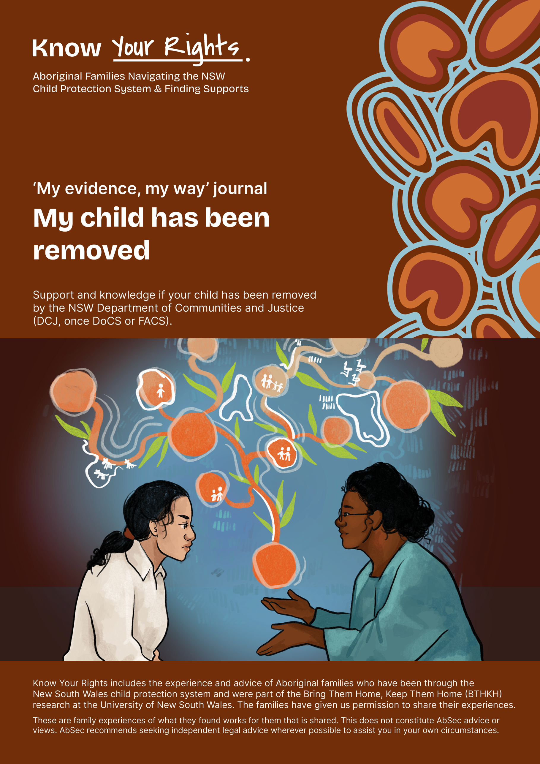

‘My evidence, my way’ journal
What I know, what I can show.

Parents understand the child protection system as a game that they do not have much power in. The NSW Department of Communities and Justice (DCJ) and other services collect evidence that is used in Court. These questions come from parents who have learned the hard way to understand or record what has happened and what might happen based on how DCJ is playing the game.
It’s up to you to choose to share what you want to with DCJ. These guides were created for you as a parent to reflect on your strengths and record your side of the story with DCJ. Please be mindful of what information is shared with DCJ. These guides were created to collect your own evidence and help assist you to reflect, for your wellbeing.
You can answer these questions however suits you best. In your head or write them down or put them in a voice recorder or do this with someone you trust and who will never use this against you.
Not all questions will be useful for you so choose what you want, when and how you want to.
Remember, you can always access your own independent legal advice to help you in your interactions with DCJ. For legal and other important contacts, see the Know Your Rights (KYR) Guide ‘Key Contacts.’

Contents
Contents 3
Harm by government and services 4
Care Plan 8
Cultural Plan 9
Summary of Proposed Plan 11

Harm by government and services
Some services or authorities like police or DCJ or health are not safe for me. Here are some questions to help me reflect on why, what happened and what this means for my involvement with DCJ or other services.

What happened
- Where was I?

- What time of day was it?

- Who else was around?

- What did I notice?

- What was the first sign that something was not right? How did I know to pay attention to that? What did this mean to me?

- What did I do?

- Who else noticed this? What did they do? What did they not do?

- What else was happening?

- How did other people respond to what I did? What did it mean to me when they responded in this way?

- Did other people do or say anything when they saw them acting in this way?

- What did I say? What did I choose not to say? How did I know to respond in this way? What did I think about before I responded?
(e.g. some parents think about what the caseworkers will do if they respond in different ways).

- How did others respond to me? Why do I think they did those things?

- What else happened? What did I notice?

- Have I ever experienced something like this before?

What did I learn or come to understand that I did not know before?
- What did I learn from this about how the system works?

- What name or word would I call the things that they did to me?

- What am I worried about now?

What does this mean for my involvement with services/authorities?
- What do I need DCJ to understand about these experiences and what will make a difference for me to be able to work with them?

- Who are the services or institutions that me and my family have interacted with? Which ones have been helpful? Which ones have harmed me and my family?
- Who did what?

- Was it a particular worker or the whole service/department who did the harm?

- How did I respond to their actions? Where was I? What did I say or do? Did I say or do what I wanted to, or did I hold back? Why did I respond this way? At that time, what did I know about the systems or people in power that shaped the way I responded?

- How did they respond to me when I responded to their harms?

- What have they done, or not done, to cause this harm?

- What were things like for me at that time and what is it like for me now? What has happened since?

- Who else knows about this? How did they respond? Did this help or did it make things worse?

- Did I tell DCJ about these experiences? Did I think that they took what I said seriously?

- Did DCJ or the service provider listen to the views and opinions that I have about my kids?

- How does the knowledge that I have about the ways that services and systems work change or influence the ways that I work with services now?

- How has the system or individual people at DCJ discriminated against me? How do I know this is discrimination? What things did I notice that made me believe that it was discrimination?

- What assumptions and biases have been made about me and my family?

- How have we responded to these assumptions and biases? (Did we try and fight back, do what they wanted, remove myself etc).

- What evidence do I have to show the harm they have done? Do I have emails, text messages, voicemail messages or written notes?

- Have I written down the things they have done? Does anyone else know about this? (e.g. my counsellor). Have they made notes about it too?

- Who were the key people that were involved? Am I able to request reports, notes and records from them?

- Have any other workers acknowledged that this happened to me?

- What does the harm done by people or systems mean for my case to keep my kids or get them back?

- How has this situation impacted my relationship with my children, partner, friends, community and family?

Care Plan
- What is in the care plan?

- What do I agree with? And what do I disagree with?

- Are there things I’ve asked to be changed? What did they say?

- Has the service with case management reviewed the case plan every year?
(They are required to, and assess where they live).

- Is there a cultural care plan as a part of the care plan?

Cultural Plan
- Does my child have a cultural plan? Was I involved in the process of creating this plan? What was this experience like for me?

- Who developed the cultural plan? Was it another agency or DCJ?

- How do I feel about what is written in the plan?

- Do I believe that the plan is being followed properly? Or does it feel like case workers are just wanting to ‘tick a box’?

- Culturally, what do I believe is important for my kids? Are there important people who are cultural knowledge holders or are there significant places that I know are important for my kids to stay connected to?

- When my kids were taken, were they placed with Kin? If not, did DCJ ask me if I wanted my kids to be placed with Aboriginal carers? Is it important to me that my kids are placed with Aboriginal carers? Why, or why not?

- Have I ever had, or been offered an Aboriginal case worker? Do I think it would make a difference to me and my kids’ experience?

- Was I asked about my hopes or desires for my child’s cultural connection and development when the cultural plan was created?

- Was my child placed outside of Country or their community of belonging? If so, did DCJ explain why? Did DCJ describe that they will do to support my child to return and spend time on Country or their community of belonging? Write down any of their responses to these questions.

- Has DCJ told me about the plans they have made to maintain my child’s contact with family, kin, Country and significant places to our family? Do I think DCJ will follow through on these plans?

- Have I asked DCJ to name who they consulted to develop my child’s cultural care plan? Ask for the person’s name, their relationship to your child, the date the person was consulted, the person who identified them to be consulted and the information they provided to develop the plan. If DCJ refuse to answer these questions, ask them why and document their responses.

- Can I ask DCJ to name the Aboriginal Community-Controlled Organisation (ACCO) that was consulted to develop my child’s cultural care plan? Ask for the organisation’s name, the representative from this organisation, their relationship to your child, the date they were consulted, the person who identified them to be consulted and the information they provided to develop the plan. If DCJ refuse to answer these questions, ask them why and write down or record on your phone/another device their responses.

- Has DCJ helped to organise any Family-Led Decision-Making sessions? If yes, were they facilitated by DCJ or an Aboriginal Community Controlled Organisation? What was this experience like for me? What came out of these sessions? Was my voice listened to, included and respected?

Summary of Proposed Plan
- When did I receive my summary of proposed plan? If it was not within two weeks of my kids being removed, why did DCJ say they gave it to me late?

- Has anyone explained to me what a Summary of Proposed Plan (SOPP) is? Do I understand what it is?

- What tasks has DCJ put in the SOPP that I must complete? Do I think that they are relevant to my situation and will help me and my kids? What things in the SOPP are relevant? What things are not relevant or not accurate?

- Do I think that the SOPP repeats the things that were in the FAP before my kids were taken? Do I think that the SOPP will set me up to fail?

- Have I written down the parts of the SOPP that I disagree with or that are untrue? How can I get support to have these things changed so that they do not end up in the next Family Action Plan?
(e.g. support from my lawyer, my advocate or support service).

- Did I have a chance to contribute to the things that went into the SOPP or was it just given to me? What things would I change about the SOPP to make it fit better for me and my kids?

- Am I the only person who must complete the actions on the SOPP? Does my partner also have to complete tasks? If my partner must also complete tasks, but I know that they will not do this, I should ask DCJ to create a separate SOPP for them so that their lack of actions doesn’t reflect badly on me. What was DCJ’s response to me asking this?

- Are the SOPP goals very clear and specific or do I think that they are vague?
(e.g. if it say’s something like ‘you must demonstrate that you have insight into the harm that parental substance use can cause to your children’, ask the worker how they want you to demonstrate insight and how they will measure it. Do they want you to write it down? Does a counsellor or psychologist have to write a letter?).

- Are there any goals that I don’t understand or agree with? Why, or why not? Do I understand the exact outcomes that DCJ want from me?

- If there are things in your SOPP that invade your privacy, ask your lawyer if this is reasonable and if this can be challenged.

- Does the SOPP give DCJ access to more information that could be used as evidence against me and my kids?

- Are there other services or organisations listed in the SOPP who will help me to complete goals and actions? Who has agreed to take responsibility to support me to complete the actions in the SOPP?

- What is the timeframe that DCJ has given me to complete these actions? Do I think it is reasonable? Do I think that I might need more time or less time to get it done?

- Do I know what arrangements DCJ has made to get funding for me to complete the actions in this plan, if I cannot pay for it myself?

- Do I know who will make the referrals to programs for me to complete the actions in this plan? Is it DCJ or my support worker?

- Do I agree with the specific information that DCJ has written about family time?
(e.g. who will the kids spend time with? How often will this happen and for how long each time? Where will it happen? Will it be supervised?).

- Since my kids were taken, has DCJ said that they don’t believe that my kids will be able to live with me in the future (also called a ‘realistic possibility of restoration’)? Is yes, can I ask them to justify this.
  - Why have they said that there is no realistic possibility of restoration?
  - What are the specific risks that DCJ believe are present? Do I agree with these risks?
  - I can ask DCJ caseworker, ‘Why are these risks not being addressed in the SOPP that DCJ has created?’.

Long-term orders
My child is on long term orders and under the parental responsibility of the Minister (PRM), what do I do now?
- How long has my kids been in away from me?

- How many placements have they been in?

- How far away are they from me?

- Are they living together with any siblings that might also have been taken from me?

- Have I been allowed to see my kids?

- How are the ways that I hold onto hope that we will be a family again?

- What is it like for me to not have them with me?

- What helps me to keep going?

- What are the things I do to stay connected with them?
(In person or in my mind/ spiritually, emotionally, culturally).

- What are the things my child does to stay connected with me?
(In person or in my mind/ spiritually, emotionally, culturally)

