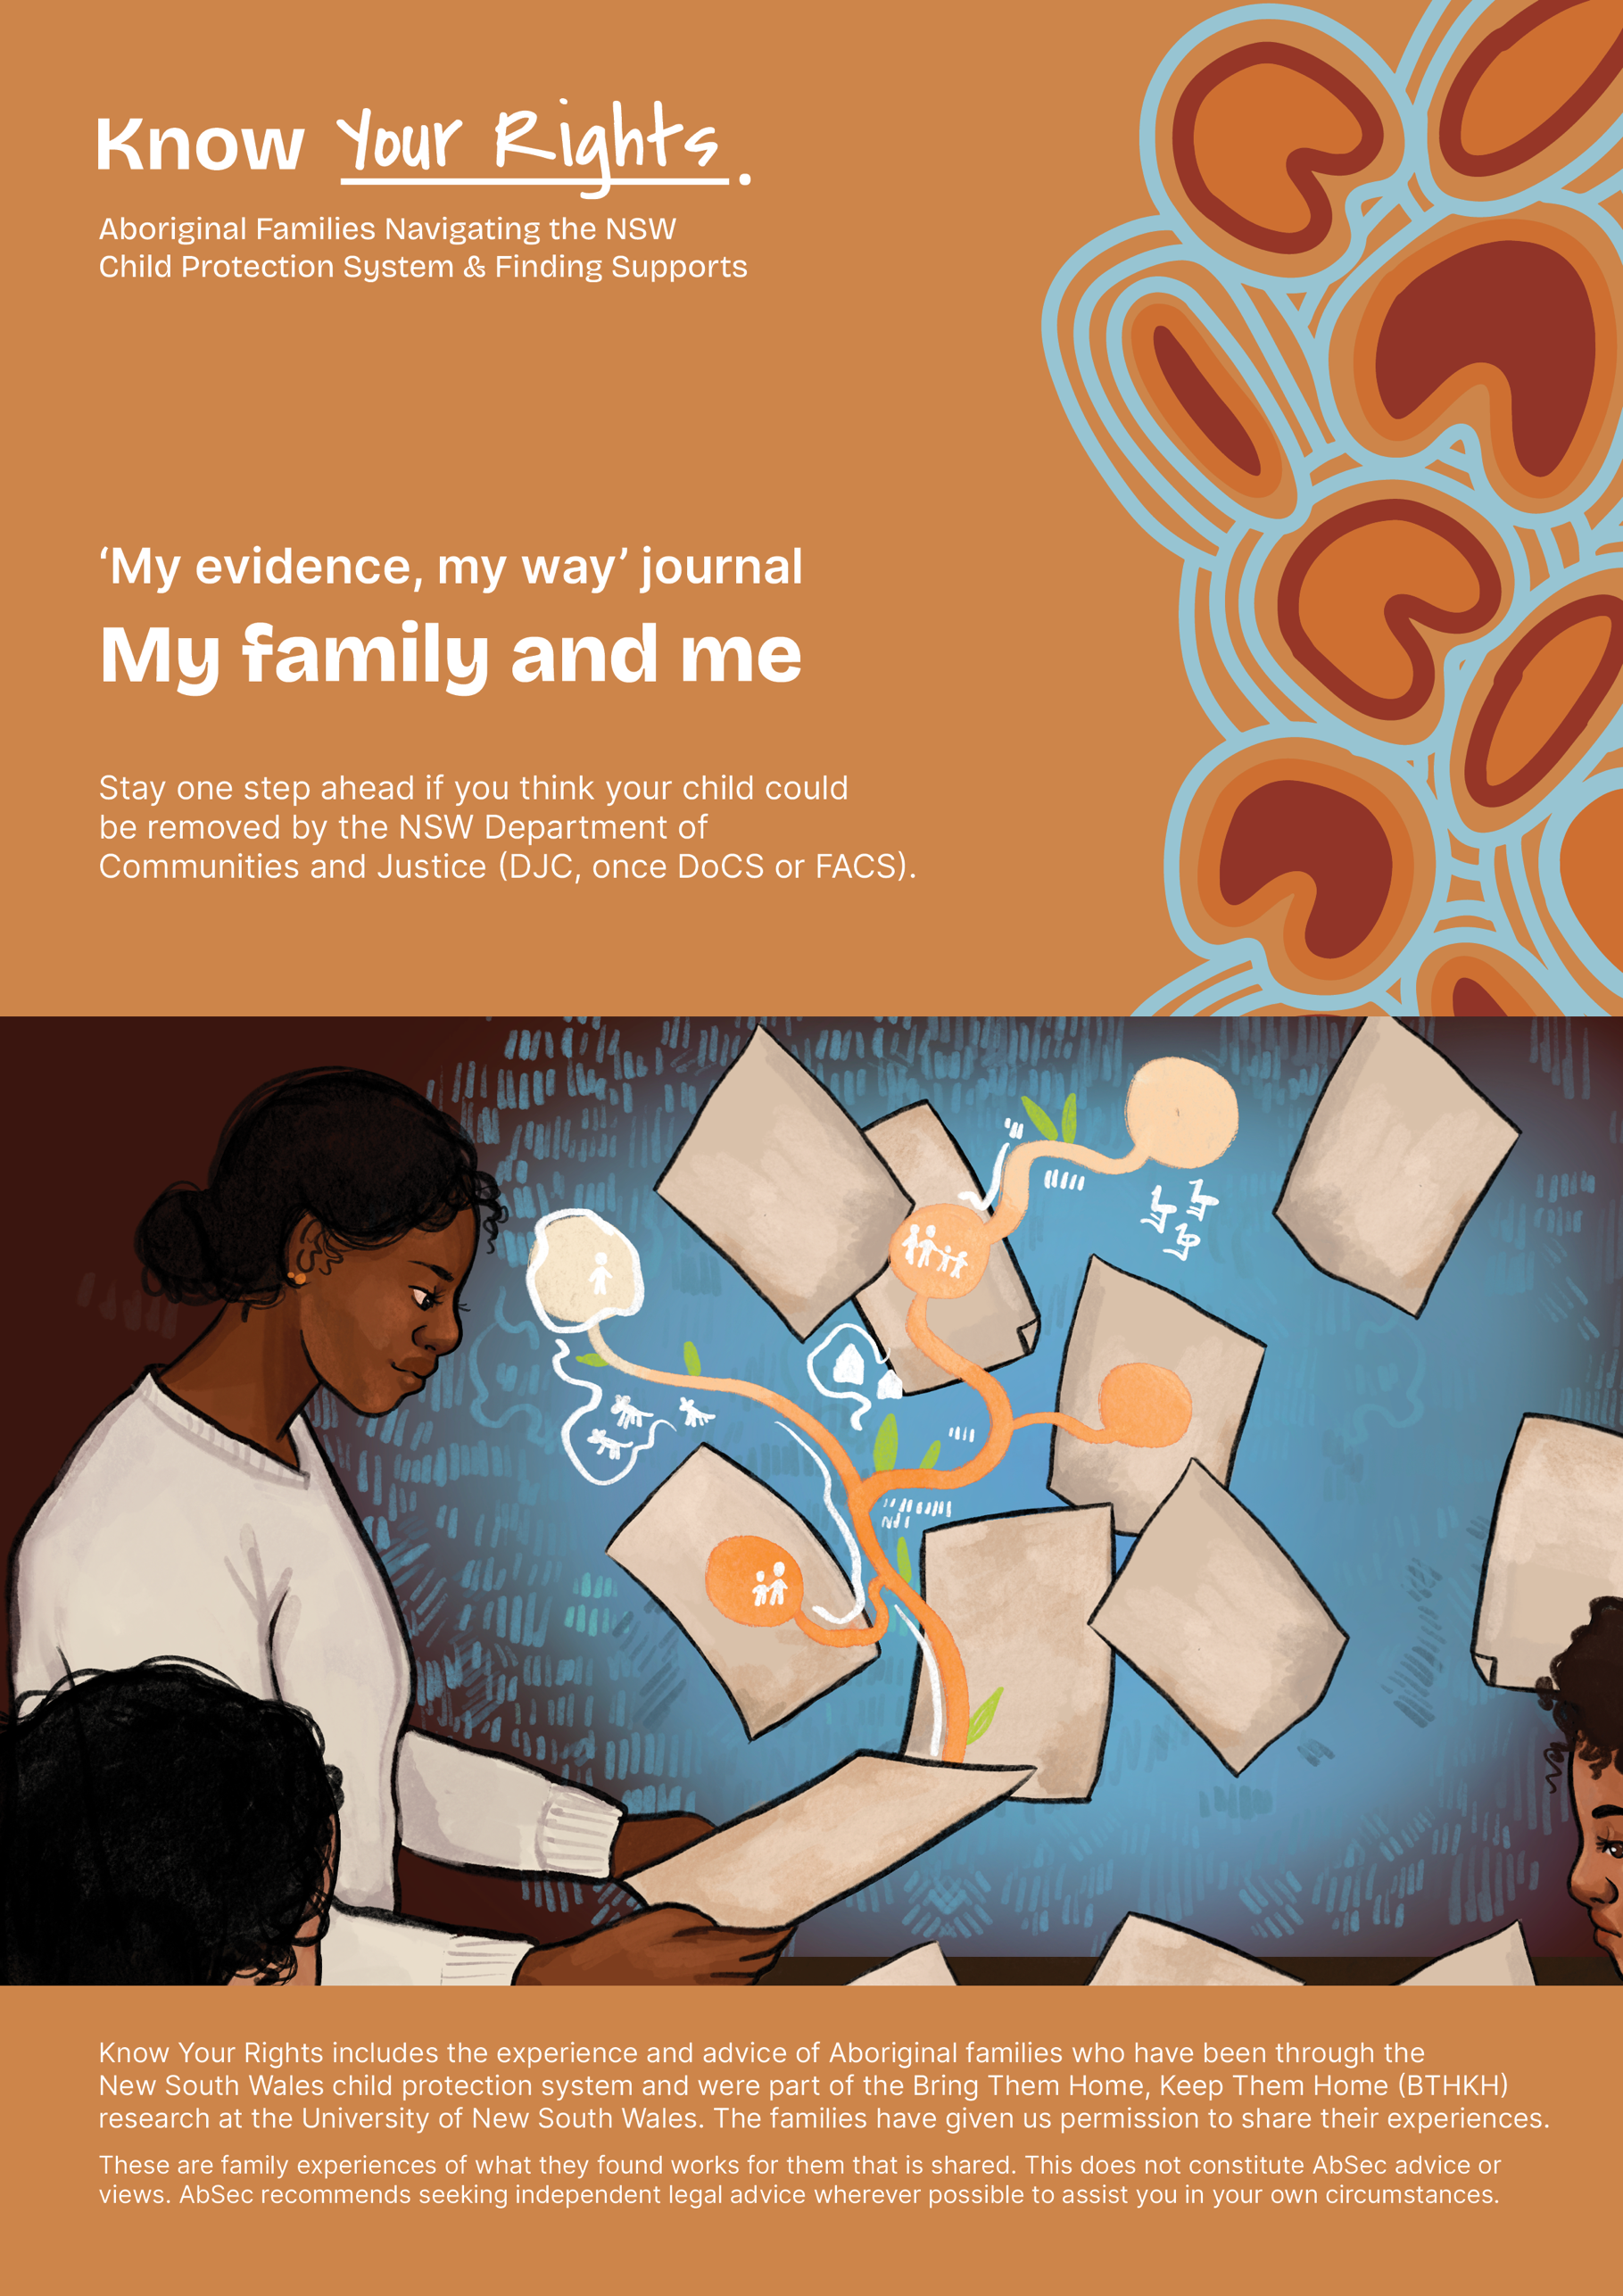

‘My evidence, my way’ journal
What I know, what I can show.
Parents understand the child protection system as a game that they do not have much power in. The NSW Department of Communities and Justice (DCJ) and other services collect evidence that is used in Court. These questions come from parents who have learned the hard way to understand or record what has happened and what might happen based on how DCJ is playing the game.
It’s up to you to choose to share what you want to with DCJ. These guides were created for you as a parent to reflect on your strengths and record your side of the story with DCJ. Please be mindful of what information is shared with DCJ. These guides were created to collect your own evidence and help assist you to reflect, for your wellbeing.
You can answer these questions however suits you best. In your head or write them down or put them in a voice recorder or do this with someone you trust and who will never use this against you. Not all questions will be useful for you so choose what you want, when and how you want to.
Remember, you can always access your own independent legal advice to help you in your interactions with DCJ. For legal and other important contacts, see the Know Your Rights (KYR) Guide ‘Key Contacts.’

Contents
Who Am I? 4
My Parenting 7
My style 7
The struggles 8
It takes a village 9
Services 9
Every child is different 10
My family and community 11
Safety 12
Services 12
The Challenges 13
Domestic and Family Violence 13
Pregnancy 17
People who act in violent ways 19
Using the system 21
Social and Emotional Wellbeing (Mental Health) 22
Pregnancy 24
Disability 27
Drug and Alcohol Use 29
Pregnancy, drugs and alcohol 33

Who Am I?
When you respond to each question, ask yourself, what proof do I have of this or who else knows this and could provide evidence of this.
- If I am worried about how DCJ treat me or the judgements they make about me, what kinds of things would I want them to know about me?

- Where does my name come from and what does it mean?

- Where do I come from? Who is my mob?

- Who is my community?

- What was my childhood like? (Memories that are special or make me feel sad or angry).

- School was a place where...

- My parents are...

- My friends are...

- Was I ever in care myself?

- The questions that I have about my upbringing are...

- Who is someone I look up to?

- What things am I good at?

- What does this say about what is important to me?

- How did I get good at these things? Who mentored or taught me?

- What things do I do to get through hard times?

- Whose spirit do I call upon when I feel like giving up?

- What are some things that I hope and dream about?

- What things do I do that DCJ don’t know about
  - What I study or would like to learn about...
  - Creative things I do...
  - Where I work or would want to work...
  - My culture
  - My community

- What things interest me?

- People say _____ (about me), but what they don’t understand is ______.
(e.g. People say I struggle with the kids but what they don’t understand is that I am getting hardly any sleep since the newborn and I just need a couple of hours help during the day so I can get on top of things).

- I am worried that DCJ will think ______ about me. I wish DCJ knew _____ about me.
(e.g I am worried DCJ will think I am not protecting my kids. I wish DCJ knew that I love my kids and would do anything for them – in fact I do what I can to make sure they are not around when their father is violent).

- When I was at school, I liked doing...

- People who I respect (think of someone) think I am good at...

- What was it like to think about these questions?

- What proof or evidence do I have of these things?

My Parenting

My style
- How would I describe myself as a parent? (What words would I use?).

- What are the kinds of things that I do for my kids every day? What do these actions say about what is important to me?

- What are the things that I do for my kids that they enjoy and makes them happy?

- Have there been times when doing the parenting was hard? What things did I do in those times that helped me? And helped my kids?

- How do I try to create safety in my home?

- What are some special things that my kids and I do together?

- How do we connect with culture and Country?

- Do we feel like we belong in our community?

- If I didn't grow up with parents or parenting role models, how have I figured out what kind of parent I want to be?
(Maybe it is based on what I would have wanted growing up or how I took care of my siblings growing up or how I see people parent that I know or on TV/in movies).

- What evidence do I have of these strengths, skills and knowledge?

The struggles
- What are some things that I struggle with?

- What do I do to try to handle these struggles?

- What else might I be able to do about these struggles? Who else can support me?

- What else would make parenting easier?

- Do I struggle with any of the kids more than the others? Why might it be like this?

- What keeps me strong in hard times?

It takes a village
- Who else cares for my kids?
(This can be people who are inside or outside of our home).

- Who is a supportive person to me? Who has given me help or support when I needed it? (e.g. family members, friends, or community).

- How do they support me? What things have they done that are helpful?

- Do I ever get any time-out to myself?

Services
- Do I have information about what services are available? If I do, what might be getting in the way of me using them? What has my experience of services been like in the past?

- How does it go when I ask for help? What happens? How do I feel? How do people respond to me?
(e.g. family, friends or services).

Every child is different
- Do I get to have special (one-on-one) time with my kids?

- If I was to write a letter to my child about what I love or appreciate about them what would I say?

- What are my hopes for my kids?

- In what ways do my kids make me a better person?

- What are some of the things that are important to my kids?

- What was it like to think about these questions?

- What proof or evidence do I have? Who else can testify to my skills and ways of responding?

My family and community

Family and Community
- Who are the family and community members that support me?
(Write down their names or collect photos of these people or things I do with them).

Connecting
- What do we do during the holidays? Do we visit any other family or go back to Country?

- What are the things that my family and community do that my kids enjoy? Who does this?

Sharing is caring
- Who else shares with the caring responsibilities of my kids?
(e.g. grandparents, family members, community members, friends).

Culture
- What does culture look like in my family and community? Do I feel like we are strong in our culture?

- How does my family and community help my kids grow up strong in themselves?

Love
- How does my family and community show their love for my kids? Who does this?

Safety
- How does my family and community create safe places and spaces for my kids? Who does this?

Services
- What other services are involved in my kids’ life?
(e.g. childcare, school, counsellors, mentors, youth centres, cultural programs, family support).

- How do they care and support us?

- What works well about these services for my kids?

- What is missing from services that would make a difference?

The Challenges

Domestic and Family Violence

(Victim Survivor)
- What has DCJ said that they are concerned about with domestic and family
violence?

- How would I describe what happened, in my own words? What kind of violence or abuse do I think this might be called?

- Who did what? How did I respond? Where was I when it happened?

- Who else was around when the violence or abuse happened?

- Who knows about what is going on? How did they respond?

- When is/was the person more likely to use violence?

- What are some ways that I have tried to protect my kids or make the violence less bad when the person is using violence? Some examples that parents from BTHKTH research have said are:
  - moved the kids into a different room from the violent person
  - organised playdates or sleepovers so that the kids are not at home during more violent times
  - asked for a housing transfer or moved houses to a place which the violent person does not know about
  - enrolling the kids in after-school/extra-curricular activities or have contact with family, community, friends
  - trying to avoid conflict by complying with the violent person’s demands.
  - maintaining medical appointments, eating/breastfeeding routines and educational routines

- Which people or services have helped or made it worse? How?

- How has the violent person’s actions impacted my kids?
(e.g. moving house/school multiple times, made us homeless, loss of contact with family or friends, loss of income and stability).

- What has DCJ asked me to do about the violence? How did I respond when they asked me to do this? How did I know to respond in this way?

- What did I notice about the ways that my kids responded to the violence? What did
they do or say? How did I respond to them? How did I know to respond in these
ways?

- Have I tried to find a lawyer or get legal advice about the violence? How did this go? What happened? How did that experience make me feel?

- We know that you can’t stop the person from using violence, but DCJ will want to
know about things that you have done to try to make your home a safer place for
your kids.
(e.g. buying new locks for the house and installing them myself or having a
locksmith do it, buying and installing security cameras and security doors or screens,
applying for the NSW Immediate Needs Support Package payment to pay for these
costs, providing receipts and invoices for this security installation work if someone
has done it for me).

- Do I have a support worker or person supporting me? How do they support me? Do I think there are better ways that they can support me? Are there any things that they are not supporting me with?

- Some parents feel that caseworkers will blame the victim of the violence, even though they are
not supposed to. What do I need other people to understand about the violence?

- What do I need the caseworker to understand about the ways that I am trying to reduce the effects of the violence on me and my kids?

- Does the person using violence ever do things like put me down or control my
parenting, that makes me feel like I need to change the ways that I show up as a
parent? What are these things?

- Are there things that are important to me or my kids that we have had to give up or
go without because of the person using violence? Has DCJ used any of these things
against me, even though it is because of the person using violence and is their fault?

- If the person using violence changes how I would usually show up as a parent, how is it different? What do I want to change if I was allowed to or had access to more
resources?

- What do I think would be different if the violence wasn’t happening?

- Write up a safety plan that includes family, friends and services (a safety plan says how you and your supporters can try and keep you safe).

Other people
- Am I experiencing other kinds of violence, either from this person or from other
people?

- Who else is acting in violent or harmful ways? How do I respond to them?

- Am I currently experiencing violence or feel fear from any institutions or
organisations? Has this happened to me before?

Pregnancy
- Have I ever experienced DFV before being pregnant?

- Was the person using violence my current partner or someone else?

- Have I experienced violence since being pregnant?

- Do I think that the violence has gotten better or worse since being pregnant?

- Do I think that the types of violence or controlling behaviours have changed since being pregnant? In what ways?

- Do I feel more unsafe from violence since being pregnant?

- Has the person using violence harmed me even though they knew that I was pregnant?

- Do I worry about how the actions of the person using violence will impact my baby?

- Do other people know about the person using violence?

- Do I feel safe to reach out to services for support?

- Are hospitals and clinics safe places for me to go?

- Have I had to skip medical appointments and check-ups for my pregnancy because of the person using violence?

- What do I want people to know about what’s going on for me right now?

People who act in violent ways

Ways I hurt others
- The kinds of things I do to control, hurt, put down, shame or control my partner and/ or family members are…
(e.g. I make sure she doesn't have enough money to go out or buy the clothes she wants, I threaten to hurt her if she doesn't do what I want, I keep a knife above the door to remind her that I will use it when I want, I threaten to call DCJ to get the kids taken off her).

- I started doing this when...

- I am most likely to use violence or try and control my partner and/or family members when...

- The things I say to myself before I start using violence or looking to control my partner and/or family members are…. These things give me the ‘green light’ to use violence because….

- How does my partner respond when I use violence? What do they say? What do they do?

- How do the children respond when I use violence? What things do they do to try to make things not so bad?

- The times when I am less likely to use violence or try and control my partner and/or family members are...

- The people who know I use violence or controlling behaviours are...

- They respond by...

- I choose to respect my partner when...

- The people who I am not violent towards are...

- The reason why I don’t hurt them is because....

- The reason I want to take responsibility for the violence the children are seeing is because...
(e.g I don’t want them to go into foster care because I know what happens there).

- When was the first time I saw violence? Who did it? Who did they do it to?

- How did I respond? Did I try to protect myself or others?

- What did this say about what is important to me?

- How can I hold onto this way of being?

- Who else can remind me that this is who I can be?

- What things have I tried to stop using violence or controlling behaviours?

Using the system
- Have I threatened my partner by saying that their children will be taken off them?

- Have I used the system against them? Have I ever threatened to tell DCJ that they are a bad parent?

- Is my violence the reason for why the DCJ is on their back?

- Have I gone to meetings with the Department to take responsibility for my actions?

- Have I breached the AVO? If so, what does this mean for what DCJ will do?

Social and Emotional Wellbeing (Mental Health)
- What has DCJ said about my mental health?

- Where do I think they got this from?

- What do I think about what they are saying?

- How would I describe my social and emotional wellbeing?

- Have I been given (prescribed) any medication?

- What are the medications like for me? Do they help me, or make me feel worse?

- If I have described myself as being depressed or having a breakdown, what do I think this might this be a response to?

- If I have concerns about my wellbeing, when did I start to worry about my social and emotional wellbeing?

- What was happening at that time? What did this mean to me?

- How much do I think my wellbeing is related to me feeling safe or unsafe?

- What would my children notice about my social and emotional wellbeing?

- How do they respond?

- What do I do when they respond to me in this way?

- What do I do to try to make sure I they get their needs met?

- How does it impact on the way that I care for my children?

- When was the last time I felt strong and well? What was happening then?

- What things do I know that are helpful for me during hard times?
(e.g. connecting with culture, community, family, Country, catching up with a friend, exercise, having time on my own).

- Can I use these supportive networks now, or do I need something different? If so, what might this be?

- Who understands what I am going through? How do I know that they understand?

- What would I like to do now to support my social and emotional wellbeing? You can use this wellbeing activity sheet to help you do that.

Pregnancy

Before birth
- Have I been pregnant before? What was this like for me?

- Have I been attending any health programs or appointments for my pregnancy?
(Keep record, if you can’t attend write down why).

- Do I feel safe or comfortable to attend health services for my pregnancy? If not, why not?

- Did I experience or was concerned that a health worker was being racist or disrespectful? What did I notice? What other forms of racism from services have I experienced and how does this shape the way I interact with authorities?
(e.g. from police, hospitals, school, housing officer etc).

- What can other people do to help make it safer for me to go to health services? How can they do this? (e.g. having a support person with me at all times).

- Do I think or do I know that I have been flagged as a ‘High risk birth alert’? Do I think the health staff have made a child protection report (ROSH report)?
(Hospital notes can be given to DCJ).

- I want this pregnancy to be... (e.g. calm, supported, not stressful).

- Do I have a plan for how I want to give birth? How do I want things to go after I give birth? What plans can be made to support me?

- What have I learned from life about what kind of parent I want to be?

- Do I feel coerced, trapped or controlled by certain people or groups to keep the pregnancy or not go through with the pregnancy? Who was it and what did they say or do?

- Do I already have a health service provider or any workers supporting me with this pregnancy?

- Is anyone threatening my safety or the safety of my baby? What have I done to try to keep me and my baby safe? What options am I considering? Are there certain things my partner (or my baby’s dad if we are not together) does or could do that would make me stressed in the hospital?

- Do I attend any antenatal health programs to help me get ready for having my baby? Do they feel like they take account of mine and my baby’s Aboriginality or that of my baby? What has this experience been like for me?

- If I have been pregnant before, what I learned last time about my body was…

- If I have experience of having other children taken from me by DCJ, what is the plan for when I give birth this time?

- Am I living in the place where I want to live when bub arrives? If not, what steps have I taken to live in a different place? What evidence do I have to show for this?

- What things do I still need to sort out before bub arrives? What support have I asked for and has it been given in ways I want and understand?

- Who else is supporting me through this pregnancy?

- Do I have all the things I need for when baby comes?

- Can I provide evidence of the changes that I have made for DCJ?
(e.g. stable housing, not using alcohol or non-authorised drugs, health outcomes).

- Am I worried that DCJ will take my baby at hospital? Why? Who else knows about this worry?

- If there is nothing that I can do to stop DCJ from taking my baby, how can I plan for someone that I trust to care for my baby until I can try to get them back?

- If DCJ is involved, have I gotten legal advice to help me keep my baby?

After birth
- Are there any culturally safe mothers’ groups or parents’ groups in my community that I can attend?

- How often am I seeing my baby? Do I want it to be more? Have I asked for this?

- Am I breastfeeding my baby? How often does DCJ/ the carers let me breastfeed bub? How has this experience been for me?

Disability
- Do I have a disability or has DCJ just said that?

- If I do have a disability, in what areas of life (e.g. remembering things, reading, writing, managing money, managing my feelings) and relationships does it impact on and not impact on?

- What do people assume about me because of my disability? How are they wrong?

- What do I wish more people understood about me and my disability?

- What am I good at? What am I proud of?

- Are there some things I might need support with my parenting, because of my disability? Who are the people in my life that understand this?

- Do I think or know that DCJ, a partner, or others are using my disability against me? How do I know this?

- How do I respond when people make assumptions about me and my ability because of my disability? Have these experiences changed the way that I interact with people? Do I feel pressured to change how I interact with people because of this?

- I don’t like or it’s not right when people do _____. I wish they would do _____ instead.
(e.g. It’s not right when people don’t include me when talking about me and my family. I wish they would include me with the supports I need).

- When speaking about my disability, I would prefer that people…

- What’s the best way for people to communicate with me?

- Who are the people that support me? How do they do this?

- How helpful is my NDIS plan and supports?

- I feel empowered when... This looks like...

- I feel respected when... This looks like...

Drug and Alcohol Use
Some questions here are about the past and some are about current use.
- What are the drugs and/or alcohol I usually use (now)?

- Are there drugs/alcohol I used to use, but don’t use anymore?

- When did I start using and why do I think I started (what was going on for me at the time)?

- When did I notice it was a problem for me?

- What makes me feel like using? Are there triggers?

- If I’ve stopped using, or have for periods of time, is there something that supports me to not use? (supportive friends/family members, a group, doing something I like to do, remembering who I am and what is important to me, keeping busy or distracting myself, taking medication, detox)

- If I do use, are there things I do to make sure it’s safer for me?
(Using with other adults, having naloxone/narcan on me, clean needles or not using needles, knowing my limits).

- How does using impact other parts of my life?
(e.g. money, negative people, mental health, physical health).

- Are there things I do to try and make sure my kids don’t go without what they need?
(e.g. vouchers from services, food banks, family takes them to school).

- Who are the people or services who help me to manage my use? How do they help me? What things do they do to help me?
(e.g. friends, meetings like alcoholics anonymous or SMART, drug and alcohol services).

- Do I work with any services that help with my drug use?
(This doesn’t just have to be drug and alcohol services; they can be holistic culturally safe services etc).

- Do I think my using impacts my parenting? In what ways?

- What does DCJ say about my drug and/or alcohol use? Is this true?

- Does using impact my parenting in the ways DCJ claim they do?

- When do I usually use drugs or alcohol?
(e.g. do I have a drink or a smoke when the kids have gone to sleep or in the morning when they go to school?).

- When I use, how do I make sure the kids are okay?
(e.g. kids stay with nan on weekends, only using when they are asleep).

- Who else knows that I use and how do they help to take care of my kids?
(e.g. they will babysit when I leave the house to use).

- Do I keep my drugs and tools in a place the kids can’t get to?

- If DCJ has said I have to attend rehab, how many rehabs have I called? Write down the names of these facilities, the length of their waitlists, the date of the last time that I contacted them and how often I contact them to see if there is a spot available for me.

- Have I kept a record of all appointments related to my drug and/or alcohol use that I have attended? If I couldn’t attend one, did I write down the reasons for why I couldn’t make it for my own records?

- Has DCJ given me the option to do a rehab program while still living at home? Or have they said it has to be in the facility? Have they made an effort to find a rehab that let’s me have my kids with me, has regular visiting, and is culturally safe?

- Did DCJ support me in finding a rehab that works for me and make efforts for this to happen?

- 23. If I am going to rehab, who are the people that can support me during that experience? Who are the people that can help with caring for my kids if I can’t be there for them? What are their contact details?

- Do I currently do urinalysis or hair follicle tests? When was the last time I had one done? What was the result of the test? Do I believe the test result was true?

- Did I pay for these tests myself or did DCJ? If I pay for them myself, is this a financial burden to me?

- How often do I complete these tests? How far do I have to travel to complete the tests? Do I think that this is reasonable expectation that DCJ have placed on me? Is this a realistic expectation if I also have other commitments?
(e.g. employment).

- Did DCJ or the service give me a copy of the drug tests I have done?

- Some parents ask DCJ to conduct random urinalysis to show that they are not using and they can’t use drug use against them. Do I think this strategy might work for me too?

- If substance use was a problem for me in the past but not anymore, how did I work to stop using? How are things different now? What are some things that I can do to maintain these changes?
(e.g. cultural supports, rehab, support groups, medications like buprenorphine or methadone, counselling).

Pregnancy, drugs and alcohol
- Does being pregnant change the way that I use?

- Do I have any plans to stop using because I am pregnant?

- If I have plans to stop using, have I spoken with a medical professional?

- Am I at a stage in my pregnancy where it is safe to stop using, or has a medical professional told me that it is safer for my baby for me to reduce my use, but not completely stop?

- What do I want people to know about what’s going on for me right now?

- If I have used substances in the past, but I don’t use anymore, how is this going?

- Has being pregnant made me want to use substances again?

- How am I coping with these urges?

- Do other people know about what’s going on for me?

- Do I have people that can support me with these urges?

- Do I have a plan for what do to when the urges are strong?

- What could other people be doing to support me?

- What do I want people to know about what’s going on for me right now?

