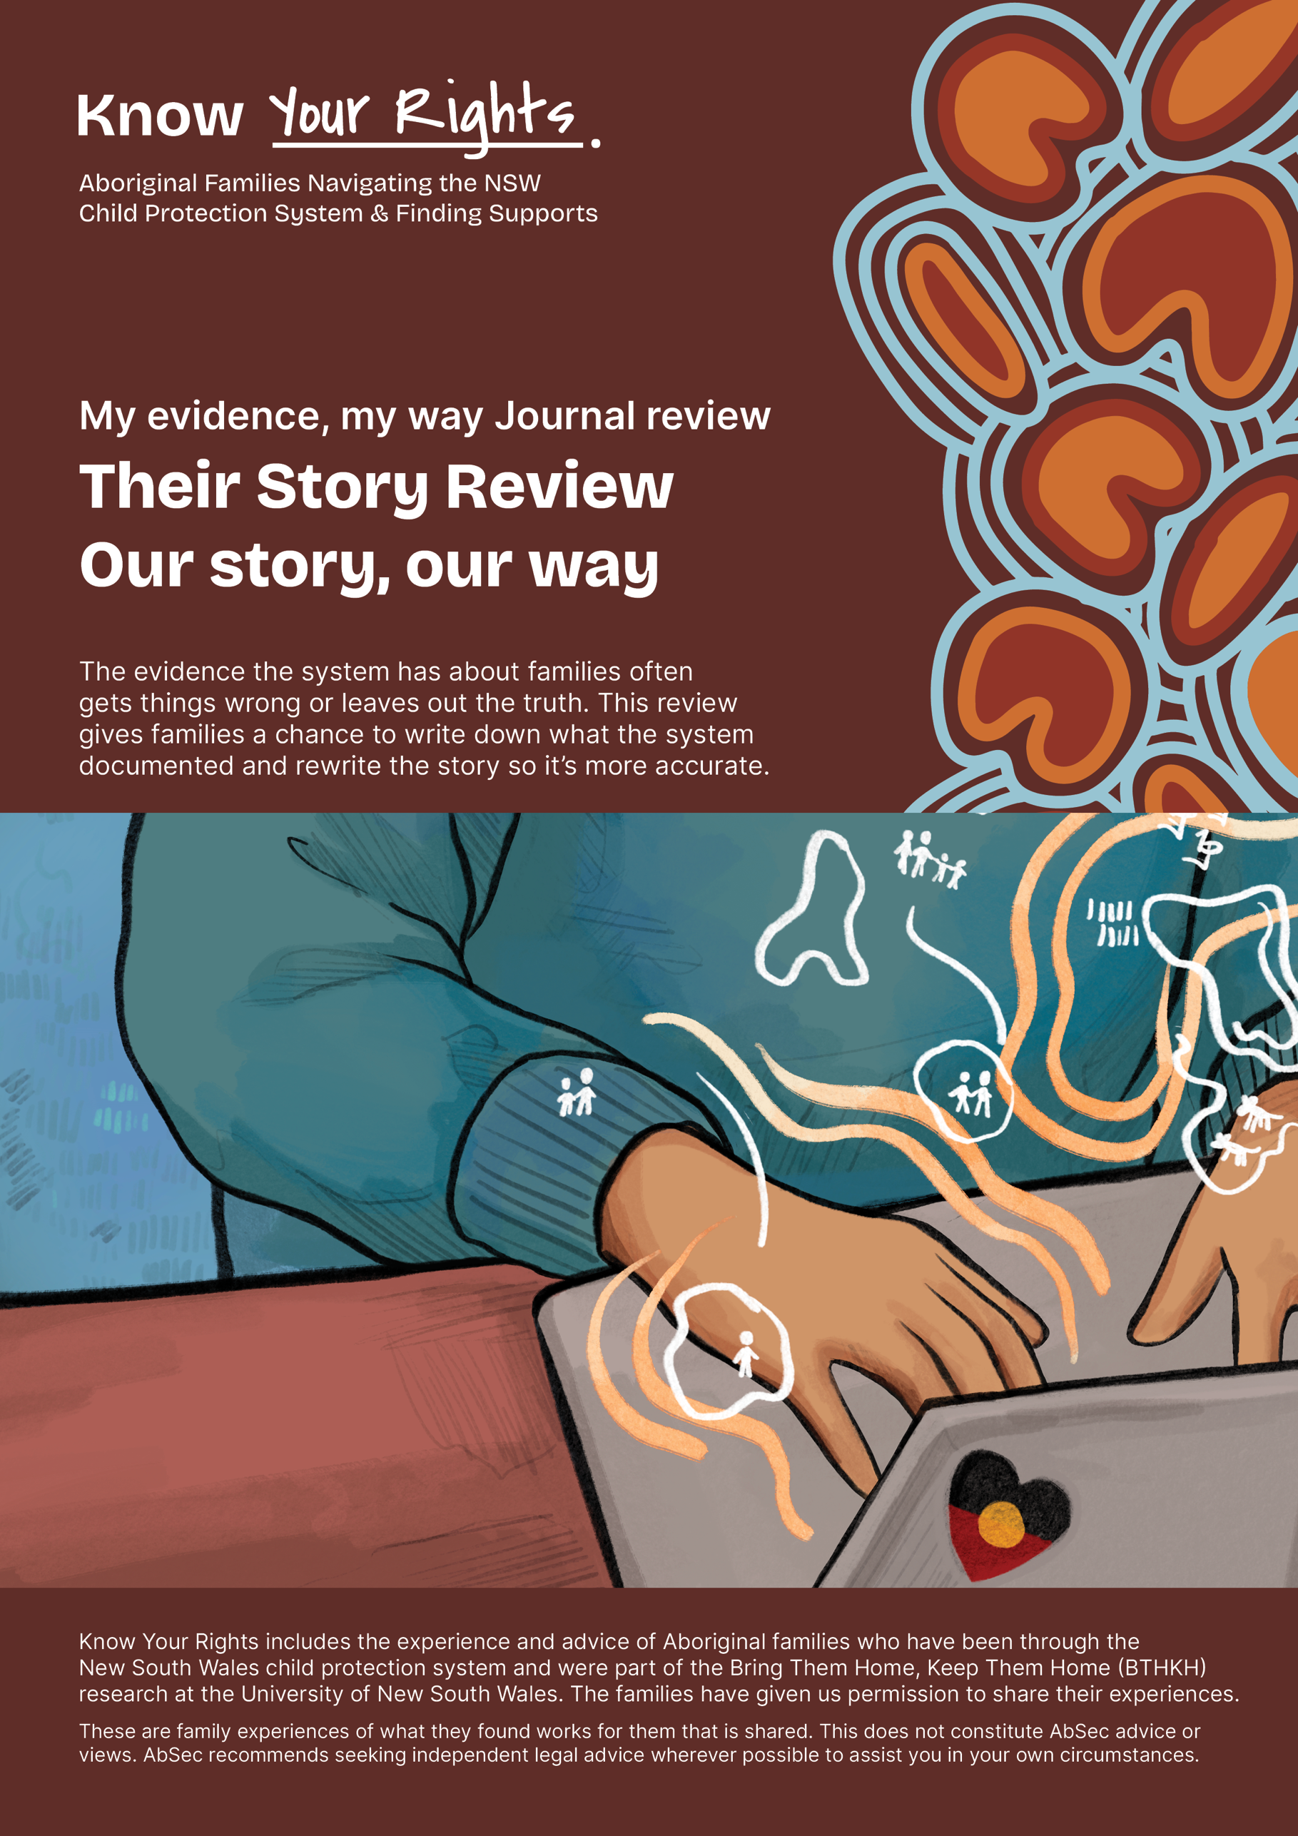

‘My evidence, my way’ journal

Their Story Review
When DCJ and service providers write about family members, they do this in ways that often mis-represent the truth. Families know this too well. This review is a way to create a space where family members can write down what they know is not true and why it is important.

Our story, our way
Our story, our way is a way to document more accurate and fair accounts of what has happened so that we can make plans that will actually make a difference for families and promote self-determination.

Contents
Their Story Review 4
What’s their story? Question prompts 6
Parents 6
My child 9
Siblings 11
Organisations responses 12
Out-of-home care (OOHC) practice 12
Family time/supervised contact 13
Parenting Capacity/Assessments 13
Restoration 13
Our Story, our way 15
Summary 15
Ending statements 17

Their Story Review
The ‘Their Story Review’ is a way to show how the children were taken and in a way that exposes the justifications (reasons given to the court) to take the children away.
Parents experience is that they are often not believed when they speak up about the lies and procedural injustice. Their concerns are silenced by support workers and lawyers and are not seen as legitimate. This silencing minimises the harm done to parents and children.
Sometimes stepping back and looking from the mountain top can help us see how we got to where we are. People can ask questions about how the process of taking their kids happened and what ideas and practices were used to do this. This is done by paying attention to:
- the language (words used),
- ideas behind the words and
- practices (things done or not done).
Parents might want support to go through this journal guide.
In the table below, parents can record what they are worried about and what they think will happen or has happened because of what was done by case workers, psychologists/social workers, psychiatrists, teachers, counsellors, carers, contact workers, health professionals, reporters etc. There are some questions that may help parents identify/document the things that they know are not okay.
You can start with the table or the questions or the template – whatever you find easiest.

Date of action taken /record:  Who | Identified concern | Potential or actual consequence for restoration (bringing my child home) | Implications for the child and the parent | Evidence of the negative consequence of this record/action | Comments/ Recommendations:
Example: 11.11.2021  Case worker wrote in safety assessment that child was on the street alone. | This is untrue as the Neighbour was watching whilst I went inside to get the baby. | I was assessed as being neglectful and that I could not cope with having so many kids. | My perspective was not presented to the Court or recorded in the assessment. | The neighbour was a witness, but DCJ refused to contact her because they know she doesn't like DCJ as she is also a client.  I also have a security camera video that shows that what was done for a couple of minutes and my neighbour was watching. | I want them to take that off the record because I have never neglected my children, and they keep bringing it up.
Summary of the concerns:

Request from the parent/child:

What’s their story? Question prompts
Parents may become aware that there is a story being built up about them and that workers often collect evidence to back-up their story. As parents read through their legal documents, they can see patterns or snowballing of allegations, like how one thing was turned into something else or something bigger, to create a way to describe parents as bad or wrong.
You may be interested in some or all of the questions below. These questions can include what happened before the kids were removed, during and after and when there were steps taken to get the kids back.

Parents
- What stories have they put together about me and any other parents/kin/grandparents?

- What strengths, skills, knowledge, abilities, understandings, requests did they not include in their paperwork or affidavit or report?

- Did they include what I said in their report?

- Why did they leave these things out?

- How did I or other family members attempt to challenge or correct the things they are saying?

- Did they include reports from my support people?

- Who benefited from leaving these people out, and what were the reasons for not including them?

- If relevant, how has my experience of being involved with the department been spoken about by the worker?

- If I was abused in care, how was it written about? Did they use it against me?

- What ideas or theories are they using to tell their stories?
(They usually use words like attachment, trauma, insight.... words that you often have to look up).
How accurate or helpful are these ideas?

- How do these stories about me/us support or get in the way of restoration (bringing my children home to me)?

- How did they use the stories that they told about us to make decisions or take action?

- Who else did they share their story with? Was it in the referrals they made to support services, and how did this shape the way they worked with me and my kids? Was this fair or accurate? If not, what were the consequences of this?

- If domestic and family violence was a part of what happened, how was this described, who was held responsible for it? Was this fair?

- Did they describe me as having mental health issues? What do I think about this? Is the way they described me fair or accurate?

- If I experienced sexual violence as an adult and/or as a child, how was this described by DCJ? Did they use it against me?

- Did the Department take seriously or factor in my experience of negative/harmful responses from people or services/authorities (e.g. police, health)?

- Was my Aboriginality or the Aboriginality of my children described as a bad thing or as something that was not good about us? How?

- Did they offer us a culturally safe service?

- How do these stories shape ongoing DCJ practice, out-of-home care case planning, and contact, supervision arrangements, family contact, and the relationship between ’Carer’ and Parent?

- What documents were shared/ not shared with out-of-home care agency? What difference does this make to me, my kids, and the work they are doing with me?

My child
- What are they saying about my child? What stories have they repeated about them?

- How did those family members attempt to challenge or correct those narratives?

- Who is left out of this picture (Who was involved and ignored)? Whose voice is not being heard?

- How was Aboriginality identified? Or has my child been deidentified?

- If relevant, how was abuse in care recorded? How was abuse in care responded to?

- Who benefited from leaving people out, and why did they say they left them out?

- What is the Department saying about why they take that position? What ideas or theories are they using to make this story? How accurate or helpful are these ideas?

- How do these narratives about my family help or get in the way of possibilities for restoration?

- How do these stories shape my child’s identity and self-worth, child’s relationship/views on parents?

- How many other children have been in and out of that household?

- DCJ say that physical stability and permanency are important. What do I think is important to my child?

- If my child has been described as having behavioural issues, what is my child doing and why do I think they are doing it? What are they trying to tell adults by acting in this way?

- If my child has a disability, health condition or is neurodiverse (e.g. autism, ADHD, dyslexia etc), how is it represented and what does this mean for case work? Is disability or other conditions being used against us?

- Is what is written in the cultural plan accurate and was I involved in writing it?

- Has my child been given a copy of the life story book? Did I have input into it? Does it include our family.

Siblings
- What is the department saying about the other kids?

- Is one child being seen as more troubled than the other?

- Are these stories different for each kid and why?

- If relevant, how was abuse in care recorded? How was abuse in care responded to?

- What is being done to support the children being close or to separate them?

- What else is important for DCJ and support people to know about my children or their relationship with each other?

Organisations responses
- What other services or authorities are/were involved?

- How helpful are they? Why/how?

- How does what they have done support or make the situation worse?

- What does this mean for the family member’s engagement with services

Out-of-home care (OOHC) practice
- How do these stories they have told about us shape what the carers think or what the OOHC agency is doing?

- Do I have copies of every care plan review?

- Did I have input into the cultural plan? Did it include family time?

Family time/supervised contact
- Who is supervising contact? What is this like for me? Is this helping my chances for restoration (my children coming home to me) or not?

- Am I ok with the following: location, quality, frequency, scrutiny, accuracy of reports, child’s experience?

- Is my child ok with the location, quality, frequency, scrutiny, accuracy of reports, parent’s experience?

Parenting Capacity/Assessments
- Was a parenting assessment done? What theories were used to justify the outcome?

- What was it like for me when I read the report? Why?

- What was ignored in the assessment?

Restoration
- If relevant, when I tried to go for a section 90 in the Children’s Court to have my kids returned to me, what barriers were put up by the system?

- Did my lawyer support me as I wanted? If not, why? What did they say or advise me to do? What did I tell them was important to me?

- What was the outcome? What does this mean for me/us if I want to try again?

- What information from affidavits was not included in DCJ’s report/affidavits?

- Were they successful? If so, why/how? If not, what got in the way?

- Who was the child restored to?

- Was the restoration to the parent who the child was removed from originally?

- Was the restoration supported? If so, how and for how long?

- If there was a relapse or adverse event during the restoration, how was this managed?

- If the children were restored and then removed; what happened? How did I respond to what happened? Was this fair?

- What do I want to happen next time my child gets to stay with me?

Our Story, our way

Summary
If the table was not detailed enough, then here are some helpful headings you might use to develop your own summary based on your answers to the question prompts above. This might be something you want to share with services or lawyers.

Name of person who wrote it:
Family/Kin (Who is in our Family and who are other important people to us?):
Cultural Considerations:
Removal experience:
The overall story they have made up about us is...

The court orders are

The care arrangements are:
The kids’ experience in care has been:
Services involved before removal and My Experience:
Services involved after removal and My Experience:
The DCJ Case Plan Goal is:
The ACCO Case Plan Goal is:
Describe family time/contact arrangements:
Describe relationship between siblings:
Describe relationship between parents and carers:
Parent hopes/worries and context of these hopes/worries:
Children's hopes/worries and context of these hopes/worries:
Carers’ hopes/worries and context of these hopes/worries:
The things I do to stay connected with my kids are:
What is getting in the way of restoration?
Carers:
Legal:
Case worker:
Family disconnection:
Fear of system:
Current households’ structures:
Cultural:
Child related:
Services:

Ending statements
- The things I want the department and the court to understand are...
(e.g. my kids didn't go to school for a few days but that was because I didn't have a car and the weather was bad, not because I was a slack mum and didn’t care. I did use drugs but that was many years ago and I don’t anymore, but I have no way to prove that I won't do it again because that is impossible).
- The reason why it is important for me that these are understood is...
- The difference this understanding will make to my child, me, my family, the carer and the court process is...
- My hope is that if this is understood, then there will be a different way forward to support restoration.

